|  |  |  |  |  |  |
| --- | --- | --- | --- | --- | --- |
| Date | 7-Dec-22 | | | Tester Name | Richard Belanger |
| Environment | Penfax - Test | | | Login used | TEST2 |
| Operating System | Windows | Version: | Update: | | |
| Software Used | Edge | Version: | Update: | | |
| Not Applicable | Version: | Update: | | |
| Release version | 22.4.1 | | | | |
| Title | M28.05- Print off a member statement | | | | |
| Test Type | Regression | | | | |
| Test Scenario | Print an Annual Statement from a Member’s account in PENFAX | | | | |
|  |  | | | | |
| Expected Results | The statement will open and print | | | | |
| Pass/Fail | Pass | | | JIRA# | N/A |

Describe your steps with screenshots:

Member Profile>Annual Statements>Go to Person Profile>Communication>Member has .pdf statements in their account

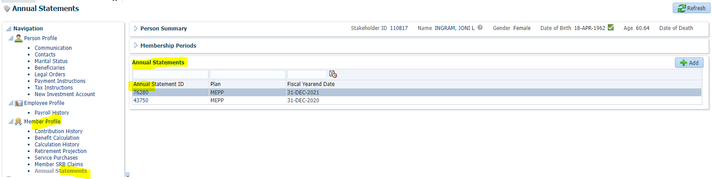

Click on File Name to bring up the .pdf statement

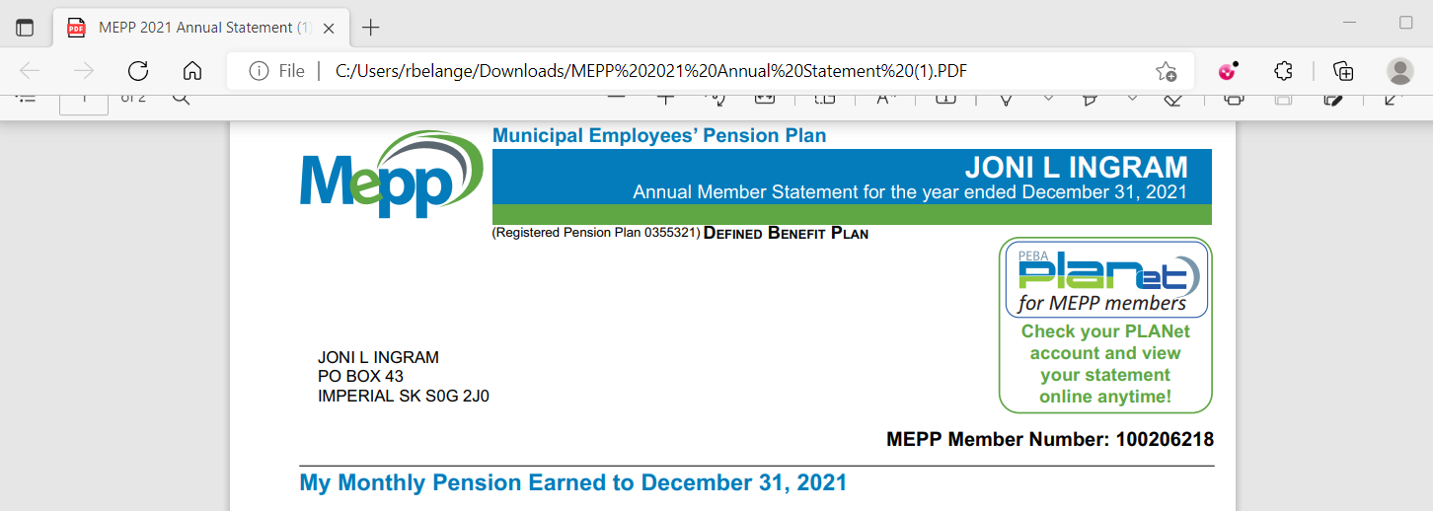

Print the statement

